2. Create a simple cloud software application for Flight Reservation System using any Cloud Service Provider to demonstrate SaaS.
Aim
To design, develop, and deploy a simple cloud-based Flight Reservation System using a Cloud Service Provider in order to demonstrate Software as a Service (SaaS).

Procedure
- A Zoho Creator account was created and logged in successfully.
- A new application named Flight Reservation System was created using Zoho Creator.
- Forms were designed to enter passenger details such as name, age, contact number, and travel date.
- Flight details including flight number, source, destination, and timing were added to the application.
- A reservation form was created to allow users to select flights and confirm bookings.
- Workflows and validations were configured to store reservation data automatically.
- Reports were generated to view booked flights and passenger information.
- The application was deployed on the Zoho Creator cloud platform and shared through a web URL.

Output
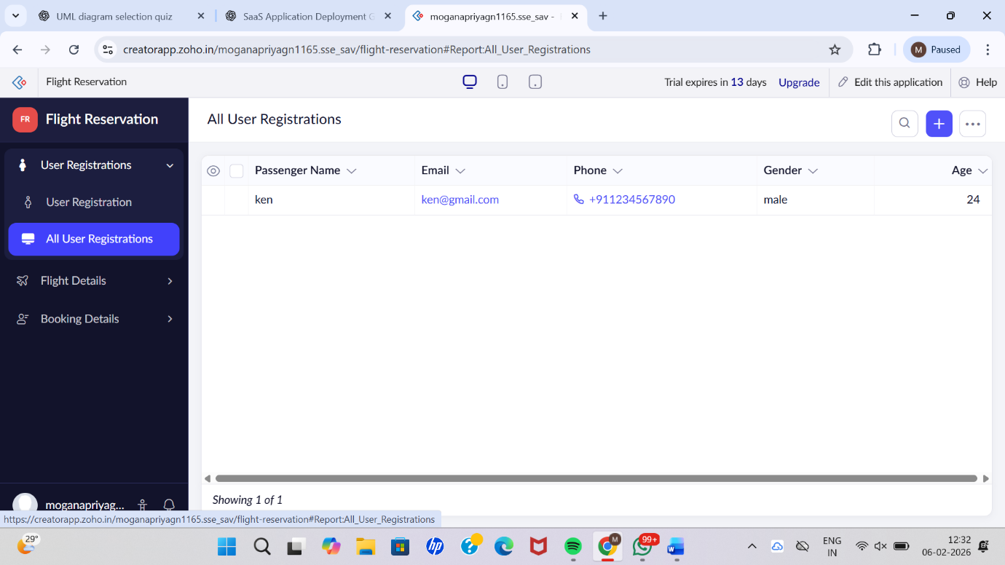

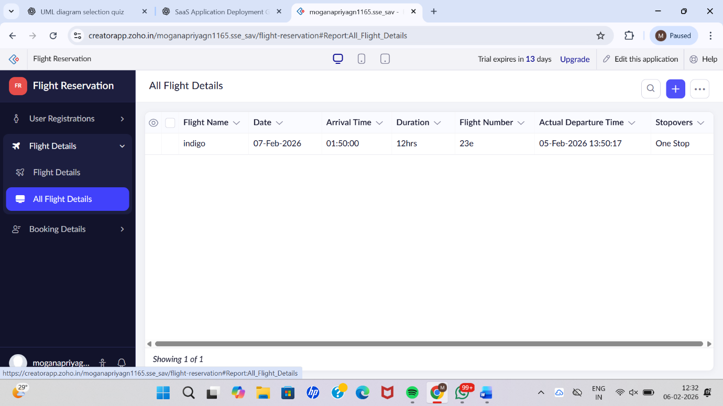

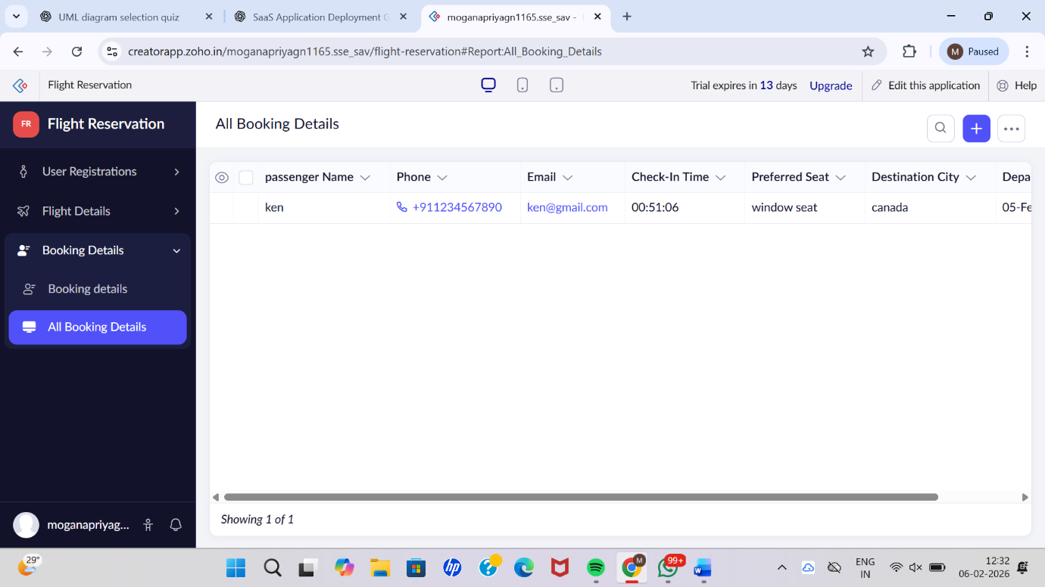

Result
Thus, a simple cloud-based Flight Reservation System was successfully created and deployed using a Cloud Service Provider. The application was delivered as Software as a Service (SaaS), allowing users to access flight booking features through the internet without installing any software locally.

